CALL FOR BARRIER CORRECTION PROJECT PROPOSALS – CHEHALIS RIVER BASIN (WRIAs 22 and 23)--

Introduction
It is anticipated that the 2017 Washington State Legislature will approve a state capital budget and there will be funding for the 2017 to 2019 biennium to be used towards fish barrier removal projects consistent with the Chehalis Basin Strategy recommended by the Chehalis Basin Board. This Call for Proposals was assembled by a technical committee of the Aquatic Species Restoration Plan (ASRP) Steering Committee.
This Call for Proposals solicits fish barrier correction projects to support the ASRP in Watershed Resource Inventory Areas (WRIAs) 22 and 23 during 2018-2019. The purpose of ASRP Barrier Project funding is to restore habitat functions within WRIAs 22 and 23 to maintain or increase the abundance and diversity of native salmonids (Table 1). Projects that benefit other “target” aquatic species will receive additional points (Table 2).
ASRP Barrier Project funding is not intended for mitigation for future flood reduction actions or flood control structures.
Table 1: Salmonids targeted by this Request for Proposals
Salmonids
Spring-run Chinook salmon
Fall-run Chinook salmon
Coho salmon
Chum salmon
Bull trout
Steelhead
Coastal cutthroat
Table 2: Non-salmonid target aquatic species
Other Aquatic Species
Pacific lamprey | Green sturgeon
Eulachon | Speckled dace
Largescale sucker | Reticulate sculpin
Riffle sculpin | Northern red-legged frog
Olympic mudminnow | Western toad
Oregon spotted frog | Van Dyke’s salamander
Coastal tailed frog | Western pond turtle

Please note: If a state capital budget is not passed by the qualifications due date, contracting may be delayed.

Eligibility
ASRP Barrier Project funding may be used for projects that meet the following eligibility requirements:

General Eligibility Requirements
- The following types of barrier ownerships are eligible for funding: city, county, tribal, private, small forest landowner (less than 2 million board feet per year).
- Fish passage projects falling under DNR’s RMAP program (large forest landowners harvesting greater than 2 million board feet per year) are ineligible for ASRP Barrier funding.
- State-owned culverts under state highways, subject to the “culvert injunction” are not eligible for ASRP Barrier funding.
- Proposals must be consistent with restoration priorities identified in the Aquatic Species Enhancement Plan (ASEP), Chehalis Basin Lead Entity Strategy, or other habitat evaluations conducted in WRIAs 22 and 23.
- Relation to current, active HRP grant funded through the Chehalis Strategy’s Aquatic Species Restoration Plan program in 2015-2017: Any work that is not currently within an HRP scope of work will need to be included in a new application as a new project.
- Matching funds are not required. Projects that have committed match included will receive higher points in the scoring and ranking process.
- The proposed project must be located in WRIA 22 or 23 (Figure 1). This area includes the Chehalis River and its tributaries, Grays Harbor estuary, tributaries feeding the estuary, and other aquatic habitats within the perimeter of WRIA 22 or 23.
- The proposal must provide a clear benefit to one or more salmonid species (Table 1).
- Projects that are intended for current or future mitigation of other projects are ineligible for funding.

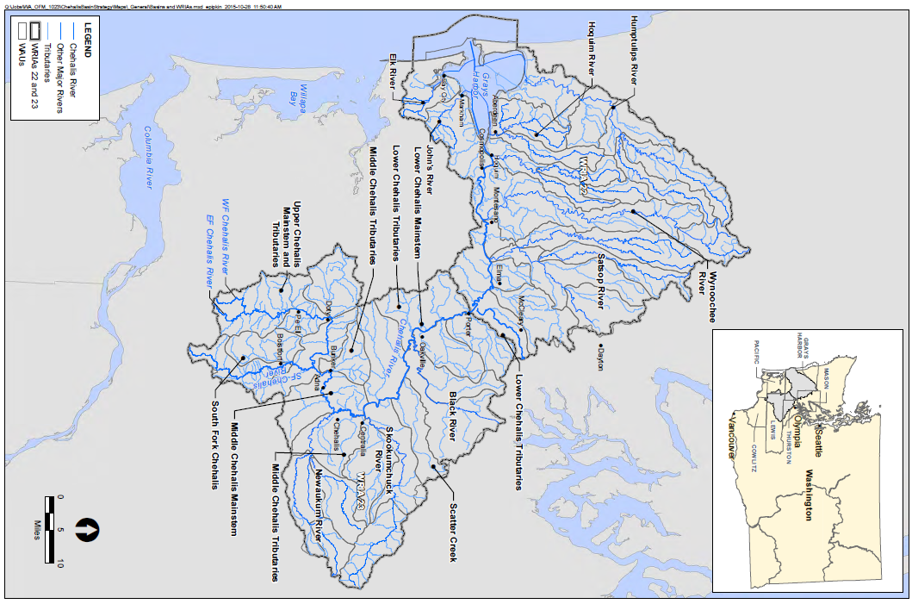
Figure 1
Map of Watershed Resource Inventory Areas 22 and 23

Eligible Applicants
- Cities
- Counties
- Conservation districts
- Federal agencies
- Municipal or quasi-municipal corporations
- Native American tribes
- Non-profit organizations, registered with Washington’s Office of the Secretary of State
- Regional Fisheries Enhancement Groups
- Special purpose districts
- State agencies

Eligible Project Activities
- Pre-construction Planning and Design – Costs for preparing pre-construction documents, engineering reports, environmental review, and permitting. All design projects must submit completed design deliverables by a licensed engineer (at minimum preliminary designs) by the completion of the contract.
- Feasibility and/or Design projects –ASRP Barrier funds are allowable for feasibility studies. This work can include reach studies and other area-specific assessments of habitat conditions and needs, and related work that lead to the identification of capital projects. Funding awards may also require a special condition that the sponsor submit preliminary designs/design reports prior to any final designs to ensure that proposed designs do not limit future restoration in priority habitats. All data, reports, and design deliverables must be submitted by the completion of the contract.
- Construction – Recipients of ASRP Barrier funding must ensure that the project complies with the approved plans and specifications. To this end, the applicant must provide adequate and competent construction management and inspection, which may involve procuring professional engineering services.
- Design and Construction Combined – Applicants can apply for a combined design and construction project. All applicable requirements for both design and construction projects apply.
- Pre- and Post-construction Assessment Elements – Project assessment both before and after project completion is important for tracking environmental and project results. Funding may be allowed for project assessments if the assessment takes place within the agreement timeframe and the assessment is part of the larger project scope. Typically, a recipient undertakes pre- and post-project assessments to characterize, identify, or quantify the existing conditions present at/on a particular site/area. This type of work should not be the primary activity of the project.
- Other Administrative Costs – In addition to the project types described above, ASRP Barrier funding may be used to cover costs for other administrative items, such as grant management.

Desired Project Activities
The ASRP Steering Committee would like to see barrier correction projects designed to optimize fish passage over the long term with resilient designs that are designed to withstand normal fluvial processes and expected changes in stream hydrology and channel morphology from climate change. To accomplish this, the Steering Committee encourages the use of the stream simulation approach described in the 2013 Water Crossing Design Guidelines (Barnard, R. J., et al. 2013, Water Crossings Design Guidelines, Washington Department of Fish and Wildlife, Olympia, Washington, available at: http://wdfw.wa.gov/publications/01501/wdfw01501.pdf) and “Incorporating Climate Change into the Design of Water Crossing Structures” (Wilhere, Atha, Quinn et al. September 2016, available at: http://wdfw.wa.gov/publications/01867/). Jane Atha is available to answer questions about regarding the content of this report (jane.atha@dfw.wa.gov). Sponsors who incorporate design criteria and recommendations from these manuals will receive additional points on their proposal.
Projects are desired in these subwatersheds: South Fork Chehalis, Newaukum, Skookumchuck, Satsop and Wynoochee.

Proposal Ranking Criteria
The following evaluation criteria will be used in scoring and ranking proposals:
1) Critical Need: High scoring projects occur in systems where fish passage is a priority limiting factors to salmon recovery, where the barrier correction would benefit multiple species, replace low passability barriers, and where there is a large linear gain to high quality habitat or a limited habitat type.
*Note: projects taking place in these subwatersheds will receive additional points: Newaukum, South Fork Chehalis, Skookumchuck, Wynoochee, Satsop.
2) Certainty of Benefits: High scoring projects use science-based methods, including climate-analyzed design and stream simulation, and have a willing landowner and are supported by the local community.
3) Ability to Implement: High scoring projects are proposed by sponsors with a track record of success and who demonstrate a knowledge of a reasonable project development, permitting, and implementation schedule. The highest scoring projects have a completed design, permit and landowner agreements.
4) Cost Effectiveness: High scoring projects provide the most benefits for a competitive cost. Cost effective projects that also include matching funds receive the highest points in this category. Factoring in the added cost of designing for climate change will not reduce a project’s cost-effectiveness score.
Proposals will be scored and ranked by a committee designated by the ASRP Steering Committee.

Application Instructions

Send project application materials to Kirsten Harma, Chehalis Basin Lead Entity Coordinator (kharma@chehalistribe.org) by 5:00 PM, December 13, 2017. Sponsors need to submit a complete proposal package which includes the following elements:
- Completed application form
- Completed detailed budget
- Project maps
- Landowner acknowledgement form
- Barrier evaluation form (optional)
- Design documents (optional)
- Any other helpful materials for project evaluation (optional)
Call Kirsten Harma with any questions: (360) 488-3232.

Project Selection
Projects will be evaluated and scored by a committee appointed by the Aquatic Species Restoration Plan Steering Committee. The Steering Committee will recommend the final project list to the Chehalis Basin Board. Based on the recommendation from the Steering Committee, the Chehalis Basin Board will recommend the level of funding to the Office of the Chehalis which administers the budget for the Chehalis Basin Strategy.
Notice of funding success will be available by after the Capital Budget is released.

