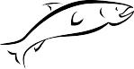 2021 Update - Overview
The last update to the Chehalis Basin Lead Entity strategy was published in 2011. Since that time, the basin has gone from being data poor to being data rich. More is known about salmonid use of the river system, and even salmon genetics. New digital tools have been developed that can help with identifying and prioritizing project types and locations. New tools for tracking and reporting on salmon recovery in the basin are available. All told, an update to the Lead Entity Strategy is due.
A full Strategy update will take more time and resources than are available to meet the 2021 update timeline. A full Strategy rewrite will need to include updates to the salmon profile for the basin, a review of the scale at which limiting factors are assessed, the prioritization of the limiting factors themselves, and the proposed actions recommended. Focus needs also to be given to which actions can be funded through the SRFB grant program, which actions the Lead Entity member organizations can implement, and which will need outside partner support to achieve.
This document includes an initial compilation of updates to the Strategy. Included are replacement chapters for select sections of the 2011 Strategy and digital resources. The original 2011 Strategy will continue to be a reference for limiting factors and recommended actions until a full update is complete.

Section Updates

These sections replace equivalent chapters in the 2011 edition

Section 4 - Guidelines for Barrier Projects ………………………………………………….……….3

Section 9 - Implementing the Strategy through Salmon Recovery Grant Program……….…10

Section 10 – Conceptual Projects and Salmon Recovery Portal …...…………………………..18

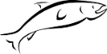Section 4 - Guidelines for Barrier Projects
The Habitat Work Group has adopted a series of guidelines to assist potential project sponsors as they develop barrier projects within the Lead Entity, regardless of the anticipated funding source. These same guidelines will also help evaluate projects brought before the Habitat Work Group for their consideration.
The Chehalis Habitat Work Group developed a Culvert Subcommittee also known as the Chehalis Fish Passage Prioritization Technical Work Group in 2017. This group consists of members of each conservation district, multiple state agencies, tribes, local governments, non-profits, and federal representation. The intent is to provide a repeatable and transparent prioritization process that will assist restoration practitioners and managers in making responsible grant funding decisions.

It is important to note that no single project guideline is more important than another. When designing or comparing projects, the merits of a barrier project should reflect how well it satisfies the guidelines in total. It is critical that a scientific approach is taken to barrier correction and prioritization.

Fish Passage Prioritization Tool

The Chehalis Basin Lead Entity, Washington Department of Fish and Wildlife (WDFW) and the Chehalis Fish Passage Prioritization Technical Work Group developed a new ground breaking scientifically based process for ranking potential barrier projects within WRIAs 22 and 23 which is accessible via an online web map. Development began in 2017 and was completed and released for public use in April of 2020. This model is intended to be updated as new barrier information is identified and when barriers are corrected. This ensures the model is up to date and as useful as possible. The Chehalis Fish Passage Barrier Prioritization Model builds upon the previous prioritization efforts that occurred in the basin that utilized metrics including amount of upstream habitat, barrier passability, and number of species present. The Chehalis Fish Passage Barrier Prioritization Model aims to assist project sponsors and grant funders in identifying fish passage projects with the highest benefits. The interactive GIS web map utilizes 11 model metrics to allow for even comparison of over 2,000 barriers throughout the basin. This effort was achievable due to the extensive scientific research occurring in the basin as well as a comprehensive barrier inventory completed by WDFW and the Lewis Conservation District (LCD). Research and extensive barrier inventories for this effort have been directly tied to Aquatic Species Restoration Plan (ASRP) funding and began in 2015.

The Chehalis Fish Passage Barrier Prioritization Model relies on criteria consisting of:
- Number of species present
- Percent passability of the fish passage barrier
- Availability of upstream habitat
- Habitat quality
- Passability and number of downstream barriers if present
- Passability and number of upstream barriers if present
- Road density
- Water quality
- Current stream temperature
- Predicted 2040 future stream temperature
- Riparian area

Applying these criteria to each of the over 2,000 fish passage barriers developed a prioritization scheme that separated barriers into 4 different priority categories. These categories are listed as priority 1-4. It is recommended that priority 1 and 2 barriers be addressed first. This information is available using the 2020 edition online web map application (Chehalis Culvert Fish Passage Barrier Prioritization Model) that is managed and updated by WDFW. Additionally, a prioritization spreadsheet showing individual category and barrier scores is available upon request or through the web map application. This web map application is also linked to WDFW’s statewide fish passage barrier database (FPDSI). For specific technical information and user guide of the web map application see WDFW’s technical Chehalis Culvert Prioritization Report. This is available on the Lead Entity website as well as WDFW’s website. WDFW will also provide training to the Habitat Work Group as needed or requested.

Focus on Subbasin as a Whole

Barrier projects need to focus on the subbasin as a whole, not just the immediate vicinity of the project. This includes evaluating what is happening upstream and downstream of the proposed corrected barrier. Factors such as land use, road densities, and ownership patterns are critical to understanding how the barrier fits within the overall future of the subbasin.

Consider Appropriate Sequencing

The process of rehabilitating a stream by removing a barrier needs to happen in a logical, sequential pattern. Project developers and evaluators need to consider:
  - The type of culverts upstream and downstream of proposed project and their potential for replacement
  - The quality of upstream substrate for spawning and rearing
  - The quality of the existing riparian corridor
  - Existing and future sediment controls
  - The stream gradient of accessible habitat made available by the project
  - Opportunities to bundle fish passage projects for cost and construction efficiencies

Develop Cost Analysis

Given the limited availability of funding and the number of badly needed barrier projects, the cost of a barrier project is a key consideration regarding its feasibility. Questions to ask are:
  - What is the cost of the barrier correction relative to the return of salmonids?
  - Does the newly accessible habitat have the potential to be productive?
  - How much match is the project sponsor making available?
  - What are other potential funding sources?
  - How is the project cost effective in terms of design and implementation?
  - Are there additional restoration or protection opportunities that can be implemented as part of the project as a whole?
  - What are the social and economic values associated with the project?

Coordination with Other Projects

Barrier correction projects need to be coordinated with other stream restoration efforts to maximize benefits. Projects that tie to other efforts, or correct the last barrier on a stream carry higher favor. Project sequencing and synergy are highly encouraged to build upon and leverage previous investments and aquatic benefits.

Understand Stream Dynamics

Stream dynamics are an important element to take into consideration when correcting a barrier. Without functional stream dynamics, newly opened stream miles may provide little long-term habitat for salmonids. Ask questions regarding
  - The overall health of the newly available habitat
  - The stability of the system itself
  - Whether there are naturally occurring processes that contribute to the health of the system (i.e., wood recruitment, aggradation)
  - Can future restoration efforts increase natural function and productivity of the upstream reaches

Determine Upstream & Downstream Barriers

The status of upstream and downstream barriers to the project is a key consideration, especially if there is strong potential that other parties will correct barriers as well. This criterion is included in the prioritization formula used in the Chehalis Fish Passage Barrier Prioritization Model but should also be discussed in the project proposal. Refer to the Chehalis Fish Passage Barrier Prioritization Model web map tool that shows fish passage barriers on the landscape as well as Road Maintenance and Abandonment Plans. Additionally, check the Washington State Department of Transportation webpage for future fish passage plans in the basin. Projects also should note the presence of natural barriers.

Landowner Willingness

Landowner willingness is a requirement of the Salmon Recovery Funding Board (SRFB) and other funding programs. Good projects demonstrate landowner cooperation and contributions.

Fish Use, and Abundance

Barrier correction projects need to identify the salmonid species that will potentially access upstream habitat. WDFW along with the Quinault Indian Nation worked cooperatively to update the Statewide Integrated Fish Distribution Layer (SWIFD) that is co-managed by WDFW and Northwest Indian Fisheries Commission (NWIFC). The SWIFD layer is the widely accepted fish distribution layer throughout the state that is continually being updated by tribes and WDFW. This layer identifies which species will benefit from fish passage corrections. The prioritization tool uses this layer to calculate habitat gain by each salmonid species present. This layer will continue to be updated throughout the basin as additional fish use information is made available. When considering fish passage corrections, evaluate the existing species abundance and the potential increase in carrying capacity by correcting the barrier.

Habitat Quality

High value barrier correction projects can demonstrate their capacity to make quality upstream habitat available to salmonids. Project proponents should demonstrate how the upstream habitat provides benefits to the various life stages and limiting factors for the species present in the stream. It is encouraged that project proponents discuss how the upstream habitat provides quality rearing and spawning for each present salmonid species’ habitat requirements.
Projects should also consider other habitat issues, such as
  - Water quality and quantity
  - The long-term use of land both upstream and downstream of the correction project
  - The capacity of local regulatory tools, such as critical area ordinances, to provide long-term protection of habitat
  - How salmonids will use the upstream habitat during their various life- stages
  - The overall benefit to natural resources, including improved stream dynamics
  - Other aquatic and terrestrial species that will benefit from the project.

RESOURCES & LINKS
Fish Passage Tools & Resources | Online Chehalis Fish Passage Barrier Prioritization Map  Fish Barrier Removal Board  WDFW Fish Passage Website
Washington State Department of Transportation  Contact: Damon Romero, WSDOT, (360)705-7413 RomeroD@wsdot.wa.gov | Fish Passage
Department of Fish and Wildlife  Contact: Curt Holt, WDFW, (360)249-4628 ext. 1212, curt.holt@dfw.wa.gov | SalmonScape
Department of Natural Resources | Family Forest Fish Passage Program  Road Maintenance & Abandonment Plans

Section 9 --- Implementing the Strategy through the Salmon Recovery Grant Program

PROJECT RECRUITMENT
Developing voluntary restoration and protection projects on private lands is the foundation on which salmon recovery in the Chehalis Basin is built. Without willing landowners, the rest of this program would be obsolete.
In the Chehalis Basin, landowner outreach and project development happens through the various groups (cities, counties, tribes, conservation districts, RFEGs, NGOs) who are eligible to sponsor a SRFB project. Staff at these organizations develop relationships with landowners in the basin and develop project concepts that help meet salmon recovery goals. Staff put together the project applications every year. The Lead Entity accepts Conceptual Project forms all year, and encourages project sponsors to submit a project idea as soon as they come up with it, whether they are ready to implement it or not. Communication between potential project sponsors, technical experts, and interested citizens happens at meetings of the Lead Entity’s steering body, the Habitat Work Group.
The Lead Entity’s Watershed Coordinator puts out a Call for Proposals each year once SRFB funding availability is announced. The Call is sent out electronically to all sponsors in the basin who have submitted applications in the past, and is also announced through press releases submitted to local newspapers, and is announced on the Chehalis Basin Lead Entity website.
The most effective project recruitment happens through one on one conversations between sponsors and landowners, among sponsors, and between sponsors and the Watershed Coordinator. Habitat Work Group meetings are an important venue where these conversations take place.
The Watershed Coordinator conducts outreach to recruit more project sponsors and partners in implementation on an ongoing basis. New players and potential project partners are increasingly showing interest in work in the Chehalis Basin. The Watershed Coordinator initiates one on one meetings to share the vision and mission of the Lead Entity and to discuss opportunities for the potential project partner to get involved.
The Watershed Coordinator undertakes additional project development outreach directly with landowners and other stakeholders. This occurs through participating in related natural resource programs and activities taking place in the Chehalis Basin. For example, 2020 activities included: Coordination with the Chehalis Basin Partnership as they implement the recommendations in the new Watershed Plan Addendum (aka, Streamflow Restoration Plan); participating on Grays Harbor and Lewis County Voluntary Stewardship Program committees as a way to identify new projects that enhance critical areas on agricultural land; participating as an ex-officio Steering Committee member of the Chehalis Strategy’s Aquatic Species Restoration Plan.

EVALUATING “FIT TO STRATEGY”

Project sponsors are encouraged to engage with the Lead Entity early and submit conceptual project ideas for screening and fit to strategy. Presentation of project ideas by project sponsors to the Habitat Work Group is ongoing throughout the year, but is concentrated in the October to January period. Early discussion of projects is a screening step for both fit to strategy and feasibility. This assumption is that by the time a project is submitted to the Lead Entity as part of the SRFB grant round, there has been a determination that the project helps the Lead Entity meet the goals of its Strategy. The work remaining is to prioritize allocation of limited funding.

GRANT PROGRAM CRITERIA
Often, many strong project proposals are submitted in a single year. A strong set of criteria is needed to evaluate the projects and assign a project score in order to determine which ones are the highest priority. The criteria and questions asked when reviewing proposals are included here. A full project ranking sheet is available in the appendix and on the Lead Entity website: www.chehalisleadentity.org.
Overall Benefit
- Critical Need (6pts). Does the proposal address a threat to salmonid habitat and clearly articulate how the threat will be addressed?
- Species (6pts). Will the project protect or restore habitat for multiple salmonid species and/or unique populations?
- Life History Benefits (6pts). Will the project benefit multiple life history stages and/or limiting life stages?
- Watershed Processes and Habitat Features (6pts). Does the project protect or restore high-priority habitat features and/or watershed processes that significantly protect or limit the salmonid productivity in the area?
- High Priority Areas and Actions (6pts). Does the proposal address a high priority action in a high-priority geographic area?
- Quantity of Benefit (6pts). Does the proposal quantify project benefits for target species? Will the project result in a major benefit?
- Synergy with other Actions (6pts). Does the project build on prior investment and is the proposal part of a strategic approach to achieving habitat goals? Will the project result in a clear net benefit greater than the proposed project alone because of this strategic approach?
Certainty of Success & Project Readiness

- Approach (3pts). Is the proposed action consistent with proven scientific methods?
- Scope & Goals (6pts). Does the project scope appropriately cover all project elements necessary to develop, implement, and complete the project? Does the proposal include quantifiable actions, goals and SMART* objectives? Is the project's scope appropriate to meet its goals and objectives?
- Budget and Cost Effectiveness (5pts). Is the project budget realistic and cost-effective?

- Team Experience (3pts). Does the project sponsor have a demonstrated ability to complete projects as proposed, on time and according to budget?
- Schedule/Sequence (3pts). Does the proposal include a logical sequence of actions and is the milestone schedule realistic?
- Permits (3pts). Are permits required for the project to proceed? If yes, what is the status of permit approval and is the permitting plan/schedule reasonable?
- Land Owners (3pts). Do the participating and affected landowners support the project?
- Support Local Values (3 pts). Does the proposal demonstrate a high level of support from local stakeholders (i.e. social, economic, and cultural groups, and/or adopted plans and policies)?
Long Term Education and Outreach (4 pts). Will the project incorporate a beneficial education/outreach program? Will the project foster a community conservation ethic through citizen involvement?
- Partnerships (3 pts). Will the project benefit from a diverse, multi-stakeholder partnership?

SRFB PROJECT LIST DEVELOPMENT

The review process for Salmon Recovery Funding Board (SRFB) grant applications submitted by project sponsors begins at the Chehalis Basin Lead Entity Level and ends with the Salmon Recovery Funding Board. Below are the steps taken by the Chehalis Basin Lead Entity to develop its annual project funding list. Statewide information on RCO requirements and processes are included in Manual 18.

Step 1
Most prospective project sponsors have completed extensive groundwork for a project proposal by November of each grant cycle. Project sponsors have selected ideas based on having a high benefit to salmon, high certainty of success, and a close fit to goals and general actions of the Chehalis Basin Lead Entity strategy. As they refine these ideas, they fill out a Conceptual Project Form, available on the Lead Entity website (www.chehalisleadentity.org) and submit it to the Lead Entity Coordinator. Since these forms can be submitted all year, the sponsor needs to indicate that they would like to submit the proposal for SRFB consideration to start the official review process.

Step 2
Soon after receiving the Conceptual Project Forms and the sponsor’s intension to apply for SRFB funding, the Lead Entity’s Habitat Work Group discusses and provides feedback on the proposals to the project sponsors at their monthly meetings. Typically, the sponsor is invited to present the proposal at an HWG meeting. These presentations may occur up to the due date to submit applications in February.

Step 3
The Salmon Recovery Funding Board process officially begins in October of each year when the Chehalis Basin Lead Entity sets the process and announces the review schedule for receiving applications under the program. The Chehalis Basin Lead Entity Coordinator is a central figure in managing this process.
Tasks that the Lead Entity Coordinator is doing in October through November include:
- Informing prospective grant applicants about the program and revisions, if any, to Manual 18
- Announcing the SRFB schedule, including the submission date for a complete application in PRISM
- Recruiting members for the Local Review Team, who will review and recommend ranking of the projects later in May. Members of the Habitat Work Group, RCO staff, WDFW staff, local citizens, and other salmonid experts typically comprise the Local Review Team.
Between the end of November and February, potential project sponsors are preparing applications in PRISM which later allows the Local Review Team and state Technical Review Panel to comment on the application. Details on what to include in applications in PRISM are outlined in Manual 18, and include at least:
- A project location/vicinity map, a detailed site or parcel map
- Site or aerial photos, if available
- Design plans or sketches that convey the intent of the project
- A detailed project description
- Estimated budget
- Evidence that the project is a high priority within the Lead Entity Strategy

Step 4
Site visits usually occur around mid-April. The Lead Entity Coordinator, the grant manager from the Washington State Recreation and Conservation Office, and members of the Local Review Team attend these visits. During the visits, which occur over two consecutive days, the Local Review Team members are encouraged to actively discuss the projects and note general feedback and questions they might have for the sponsors. After the visits, the Lead Entity Coordinator collects Local Review Team written feedback and questions about the project and provides them to the sponsor through PRISM, generally within a week of the site visits. The state Technical Review Team will provide feedback in PRISM at a later date. Project sponsors use this feedback to improve their applications.

Step 5
The Local Review Team meets in May, at a time that works for everyone on the team. They rely on their professional and local experience and the Chehalis Basin Lead Entity criteria (Section xx) as the basis for evaluation of each application. A note taker is encouraged to attend these meetings so that the conversation around each project is well documented.
Since the review members rank and score all projects during an intense one-day period, there is often a need to finalize the scores during a follow-up call. The Lead Entity Coordinator reviews scores, looking for any math errors or remaining questions from the notes and makes the call on whether to convene the committee shortly after the ranking meeting.
At their June meeting, the full HWG in its role as Citizen Committee reviews the project list. If there are any concerns with the project ranking, they may ask the Local Review Team to reconvene, respond to the HWG comments, and adjust the list as necessary. If there are not concerns, they will vote on the final Lead Entity Project List. Depending on the amount of money allocated to the Lead Entity, there will be a cut-off point as to which projects are recommended move forward within a recommended project list. Projects below that funding line have the option of being recommended as Alternates should additional SRFB funding become available.

Step 6
The Coast Salmon Partnership, in its capacity as the Regional Organization, prepares and submits to the Recreation and Conservation Office in August its regional assessment of the Lead Entity’s project list. Prior to this recommendation, the CSP reviews all regional requests. If there are some Lead Entities with a greater need than amount of funding available, the group will attempt to fill that need from another Coast Lead Entity that can’t use its full annual allocation. This process allows excess funding to stay within the Coast region, rather than being allocated elsewhere in the state.

Step 7
At their September board meeting, the full SRFB convenes for final funding approval. They consider the Lead Entity recommendations, comments from Coast Salmon Partnership, reports from the Technical Review Panel and RCO staff, and public comments before making a final decision on grant awards.

Section 10:
Conceptual Projects & Salmon Recovery Portal

CONCEPTUAL PROJECT LISTS
The Chehalis Basin Lead Entity assembles an inventory of conceptual projects as a proactive step towards strategically directing habitat restoration and protection within the Chehalis Basin.
Conceptual projects are the first phase in project development. A conceptual project may range in scope from a broad idea to one that is ready to implement. Projects are “conceptual” because they may not be fully ready for implementation. The reasons may vary, but typically, it is because a project lacks a sponsor, community buy-in or support, or enough information to move forward.
There are three advantages to having the Lead Entity compile this inventory of conceptual projects. The first one is that using the expertise of Lead Entity members, a project can increase in quality as the group fine-tunes it. Waiting until a Salmon Recovery Funding Board (SRFB) grant cycle to have this happen can be a poor use of both a project sponsor’s and the Lead Entity’s time. The time a project spends maturing on a conceptual inventory list will give Lead Entity members the opportunity to properly vet it, which will in the end increase its chances of becoming a stronger, fundable project – whether by a SRFB grant or another funding opportunity.
A second advantage to the conceptual project inventory is that it encourages the development of the “tough” projects – those large, complex ones that often take more expertise and resources than an individual sponsor can muster. These types of projects demand more of a team approach needing broad expertise in habitat, community development, and project management.
The final benefit to the conceptual project inventory is that the Lead Entity can use it to recruit sponsors for potential projects. For example, WDFW currently updates a list of prioritized fish barriers throughout the Chehalis Basin and recommends that sponsors correct the top third of these barriers. Using a conceptual project inventory accessible to public inspection may connect a potential, interested sponsor with a specific project from that list. In addition, if that sponsor lacks expertise in developing a project, it could receive assistance from the Lead Entity.
The tool available for housing the conceptual project inventory is the Salmon Recovery Portal (SRP). The SRP was born out a partnership formed between the Washington Department of Fish and Wildlife and Washington’s Lead Entity organizations and is now owned and managed by the Recreation and Conservation Office. All partners needed a public website that provided current information about restoration and acquisition projects. The intent was to have an interactive web tool that could share information about conceptual, proposed, active, and completed projects with policy makers, funders, the public, and other stakeholders. The outcome of the effort now allows each Lead Entity to communicate visually its habitat goals, strategies, and project efforts.

DEVELOPING THE CONCEPTUAL PROJECT INVENTORY
The Chehalis Basin Lead Entity’s site in Salmon Recovery Portal is organized by watershed geography.
Each subwatershed, or “Management Unit,” is a main folder, with projects in the folders contained within it. This graphic shows the list of Management Units.
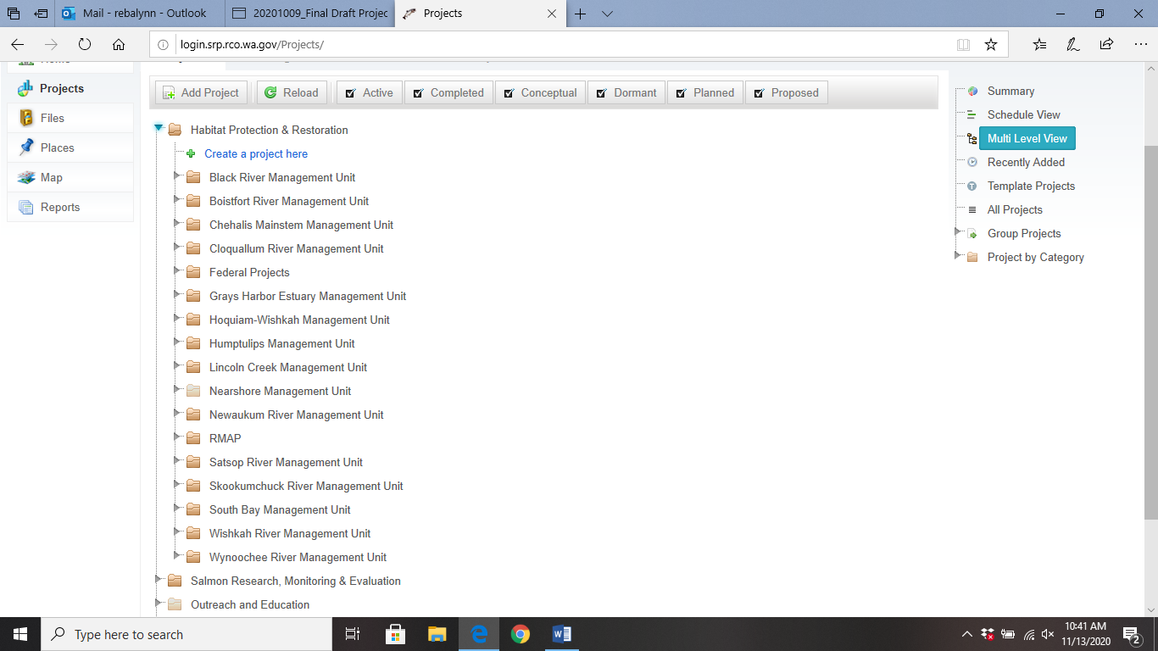

Within each of the Management Unit folders are folders for each of the tributaries that have projects. An example of what this looks like is provided in the image below.
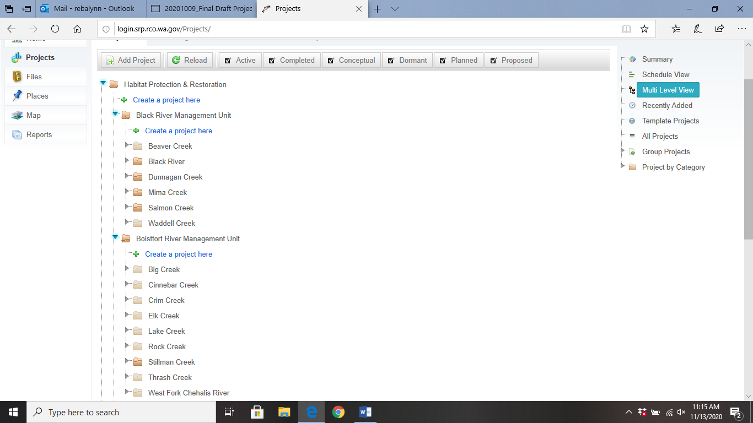

Each of the tributary folders contain a link to the individual project webpages:
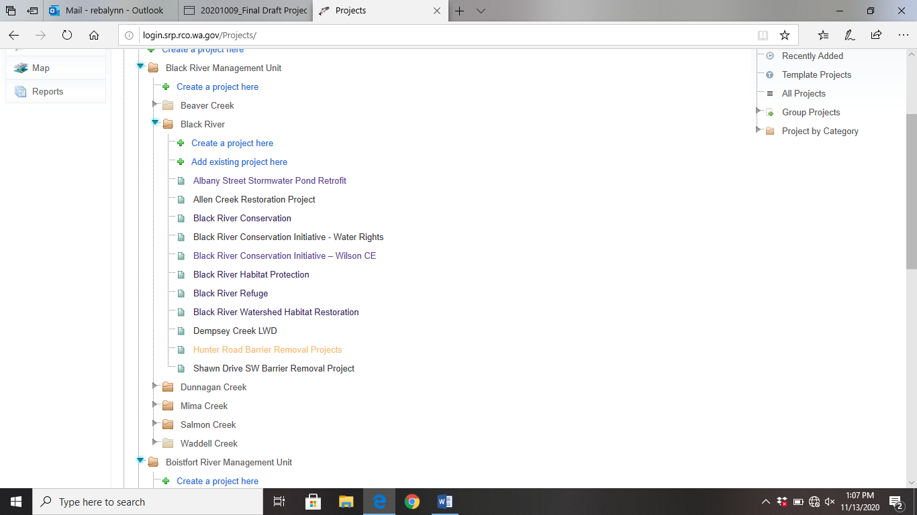

The project information pages contain various tabs with information on the project location, goals, funding sources (if any), and metrics about what the project will achieve. For a project to be entered into the SRP it only needs the very basic information available on the first tab.
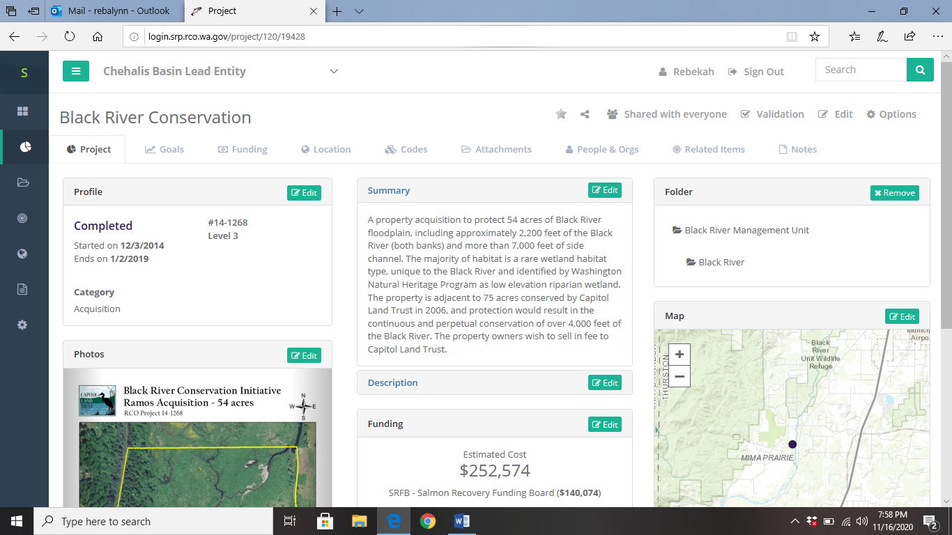

OUTREACH

The Lead Entity’s goal is to continue developing strong projects aimed at benefitting large populations of salmonids classified as priority stocks under The Chehalis Basin Salmon Habitat Restoration and Preservation Work Plan for WRIA 22-23 (Strategy). Outreach to solicit project concepts in ongoing throughout the year, but intensifies during the early part of the SRFB grant cycle (see Section 9).
Parties that want to work in the basin but who don’t have a project idea in mind can start by reviewing information about the needed actions in each geographic area. The Lead Entity website provides links to Management Unit documents (www.chehalisleadentity.org/documents). Each summary provides a description of the sub-watershed, its major tributaries, land uses, and anadromous fish stocks. It also outlines limiting factors, symptoms, causes, and general recommended actions for each major river or stream.

MANAGING & PRIORITIZING CONCEPTUAL PROJECTS
The Chehalis Basin Lead Entity process is for any project sponsor to submit a Conceptual Project Form before formally applying for SRFB funding. The Habitat Work Group generally receives presentations on conceptual projects on a monthly basis from September until January, though these are welcome any time. The purpose of these early project presentation is to allow for HWG members to provide feedback on projects in order to get them “project ready” for funding under SRFB or other grant programs.
If there comes a time where there are many more conceptual project ideas in the project database than would be reasonable to put forward for SRFB funding, the Habitat Work Group may choose to vet the project concepts. This could be done by the local/technical review team appointed by the Habitat Work Group. Questions to ask when reviewing concepts and evaluating their merit include:
- Salmonids
Does the project benefit the multiple salmonid species at multiple life stages?

- Limiting Factors
Does the project take a Tier 1 or 2 action relevant to its location?
Does the project address multiple limiting factors?

- Protection
Does the acquisition address an imminent threat to salmonid habitat?
Will acquisition protect a functioning habitat system and sustain critical habitat processes?

- Education and Outreach
Does the project include a temporary or on-going Education & Outreach program?
- Cost
What is the project’s cost in relation to similar ones recently completed?
What is the project cost relative to benefit to salmonids?
- Climate Change
Does the project account for future conditions (e.g. temperature, flow, plant distribution) in its design?

- Likelihood of Success
Is it likely that current or future land uses or human activities could reduce this project’s benefit?

The following form is an optional guide to quickly vet each of the projects submitted to see if they should be advanced for funding consideration:

CONCEPTUAL PROJECTS EVALUATION FORM
Project | Salmonids | Limiting Factors | Protection | Education & Outreach | Cost | Climate Change | Likelihood of Success | Selected (y/n)
Conceptual Project 1
Conceptual Project 2
Conceptual Project 3

